# (PyH)2Dy(NO3)5

# PSEUDOSPIN HAMILTONIAN TENSORS

|  |  |  |  |
| --- | --- | --- | --- |
| KD | g_x | g_y | g_z |
| 1.0 | 12.44671505325647 | 6.98693983393028 | 1.01934000968195 |
| 2.0 | 0.35193692695136 | 2.77726220161961 | 7.48069690438024 |
| 3.0 | 0.85080726070592 | 3.8299724418542 | 13.62169949503024 |
| 4.0 | 1.97429898644903 | 3.36158799375915 | 13.61414351481044 |
| 5.0 | 9.9574264692667 | 7.58102931564172 | 0.08802396404572 |
| 6.0 | 6.68026981087314 | 4.28540429233011 | 0.71398251143476 |
| 7.0 | 0.65075648105894 | 5.17382642654621 | 11.02504033149191 |
| 8.0 | 2.46795725522786 | 3.53031327778232 | 14.82057536241076 |

# AB INITIO BLOCKING BARRIER

|  |  |  |  |
| --- | --- | --- | --- |
| KD | l+, muB | l-, muB | E, cm-1 |
| 1.0 | -0.50967 | 0.50967 | 0.0 |
| 2.0 | -0.5774951 | 0.5774951 | 34.0783377 |
| 3.0 | -1.0203245 | 1.0203245 | 84.1244252 |
| 4.0 | -6.7539635 | 6.7539635 | 125.4213542 |
| 5.0 | -0.3338349 | 0.3338349 | 181.221586 |
| 6.0 | -2.9269023 | 2.9269023 | 208.4309456 |
| 7.0 | -4.8322756 | 4.8322756 | 260.9581821 |
| 8.0 | -6.7468476 | 6.7468476 | 308.8631327 |

# QTM, ORBACH, MTRIX ELEMENTS

|  |  |  |  |  |  |  |  |
| --- | --- | --- | --- | --- | --- | --- | --- |
| 1+ | 2+ | 3+ | 4+ | 5+ | 6+ | 7+ | 8+ |
| 3.2389424812 | 1.53746110775 | 0.884666549558 | 0.784967998462 | 0.662973596669 | 0.534972873935 | 0.0929588133394 | 0.0650308541765 |
| 0.0 | 1.38117300863 | 1.33188349557 | 1.45336436821 | 0.388082804705 | 0.847271160504 | 0.285543033861 | 0.128780470147 |
| 0.0 | 0.0 | 1.86184088796 | 1.03316167649 | 0.628695712858 | 0.952450548967 | 1.34404959815 | 0.129916210767 |
| 0.0 | 0.0 | 0.0 | 0.898135939196 | 1.47224659476 | 1.76980337 | 0.838805301394 | 0.333427126408 |
| 0.0 | 0.0 | 0.0 | 0.0 | 2.15084644222 | 1.81837894127 | 0.540578444908 | 0.739134413567 |
| 0.0 | 0.0 | 0.0 | 0.0 | 0.0 | 0.995348176038 | 0.643541634127 | 1.3927444074 |
| 0.0 | 0.0 | 0.0 | 0.0 | 0.0 | 0.0 | 1.17767199667 | 1.46491124957 |
| 0.0 | 0.0 | 0.0 | 0.0 | 0.0 | 0.0 | 0.0 | 1.05568635317 |

# DIRECT MTRIX ELEMENTS

|  |  |  |  |  |  |  |  |
| --- | --- | --- | --- | --- | --- | --- | --- |
| 0 | 1 | 2 | 3 | 4 | 5 | 6 | 7 |
| 0.169890001615 | 2.67370923207 | 0.472058021701 | 0.535506492631 | 1.12715199878 | 0.39458690357 | 0.127782204804 | 0.101639771482 |
| 0.0 | 1.11179464496 | 2.33923588217 | 0.924199202104 | 0.460237133007 | 1.07957884967 | 0.53775289725 | 0.149836345362 |
| 0.0 | 0.0 | 2.65758687304 | 0.631251399931 | 0.662457626803 | 0.592597786315 | 1.06968969891 | 0.755176734428 |
| 0.0 | 0.0 | 0.0 | 2.63082653158 | 1.42157356327 | 1.00549292015 | 0.830638615319 | 0.986772321267 |
| 0.0 | 0.0 | 0.0 | 0.0 | 1.85448838755 | 2.34724412196 | 0.847257963376 | 0.785259234409 |
| 0.0 | 0.0 | 0.0 | 0.0 | 0.0 | 1.42389016679 | 2.18278911262 | 1.12951978299 |
| 0.0 | 0.0 | 0.0 | 0.0 | 0.0 | 0.0 | 2.58130890038 | 1.96182335025 |
| 0.0 | 0.0 | 0.0 | 0.0 | 0.0 | 0.0 | 0.0 | 3.63471905696 |

# Energy_diagram

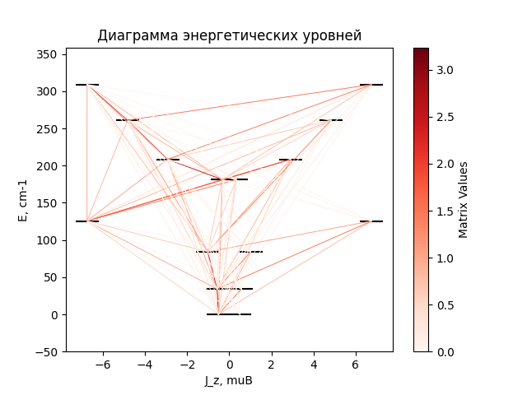

# CF_parameters

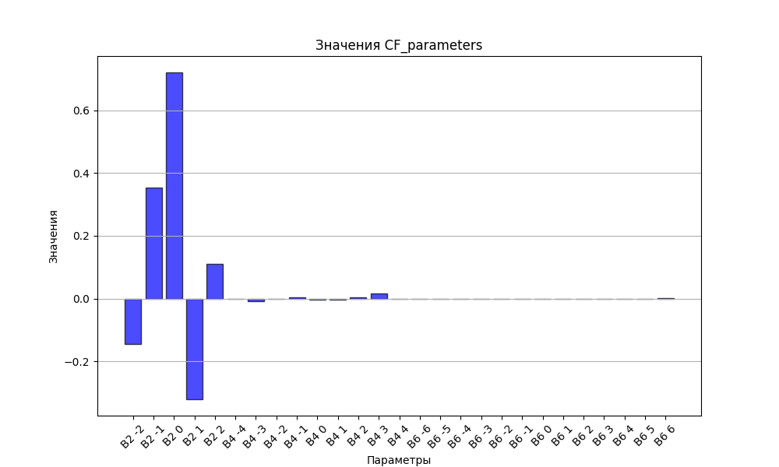

# CHI * T

|  |  |
| --- | --- |
| T | CHI * T |
| 1.0 | 6.3876115 |
| 2.0 | 6.8079213 |
| 3.0 | 7.0797181 |
| 4.0 | 7.3282982 |
| 5.0 | 7.5698124 |
| 6.0 | 7.8075184 |
| 7.0 | 8.0412524 |
| 8.0 | 8.2695984 |
| 9.0 | 8.4908402 |
| 10.0 | 8.703463 |
| 11.0 | 8.9063728 |
| 12.0 | 9.0989412 |
| 13.0 | 9.2809565 |
| 14.0 | 9.4525356 |
| 15.0 | 9.6140316 |
| 16.0 | 9.7659499 |
| 17.0 | 9.9088826 |
| 18.0 | 10.0434581 |
| 19.0 | 10.170307 |
| 20.0 | 10.2900395 |
| 21.0 | 10.4032313 |
| 22.0 | 10.5104166 |
| 23.0 | 10.6120854 |
| 24.0 | 10.7086835 |
| 25.0 | 10.8006144 |
| 26.0 | 10.8882421 |
| 27.0 | 10.9718945 |
| 28.0 | 11.0518666 |
| 29.0 | 11.1284244 |
| 30.0 | 11.2018075 |
| 31.0 | 11.2722322 |
| 32.0 | 11.3398944 |
| 33.0 | 11.4049715 |
| 34.0 | 11.4676248 |
| 35.0 | 11.528001 |
| 36.0 | 11.5862344 |
| 37.0 | 11.6424475 |
| 38.0 | 11.6967528 |
| 39.0 | 11.7492538 |
| 40.0 | 11.8000455 |
| 41.0 | 11.8492161 |
| 42.0 | 11.8968466 |
| 43.0 | 11.9430125 |
| 44.0 | 11.9877837 |
| 45.0 | 12.0312252 |
| 46.0 | 12.0733975 |
| 47.0 | 12.1143571 |
| 48.0 | 12.1541568 |
| 49.0 | 12.192846 |
| 50.0 | 12.2304711 |
| 51.0 | 12.2670754 |
| 52.0 | 12.3026997 |
| 53.0 | 12.3373824 |
| 54.0 | 12.3711598 |
| 55.0 | 12.4040659 |
| 56.0 | 12.436133 |
| 57.0 | 12.4673915 |
| 58.0 | 12.4978702 |
| 59.0 | 12.5275966 |
| 60.0 | 12.5565964 |
| 61.0 | 12.5848943 |
| 62.0 | 12.6125137 |
| 63.0 | 12.6394769 |
| 64.0 | 12.665805 |
| 65.0 | 12.6915183 |
| 66.0 | 12.716636 |
| 67.0 | 12.7411766 |
| 68.0 | 12.7651577 |
| 69.0 | 12.7885962 |
| 70.0 | 12.8115081 |
| 71.0 | 12.8339089 |
| 72.0 | 12.8558135 |
| 73.0 | 12.8772362 |
| 74.0 | 12.8981905 |
| 75.0 | 12.9186897 |
| 76.0 | 12.9387463 |
| 77.0 | 12.9583726 |
| 78.0 | 12.9775802 |
| 79.0 | 12.9963805 |
| 80.0 | 13.0147844 |
| 81.0 | 13.0328024 |
| 82.0 | 13.0504445 |
| 83.0 | 13.0677207 |
| 84.0 | 13.0846404 |
| 85.0 | 13.1012127 |
| 86.0 | 13.1174465 |
| 87.0 | 13.1333504 |
| 88.0 | 13.1489327 |
| 89.0 | 13.1642013 |
| 90.0 | 13.1791642 |
| 91.0 | 13.1938288 |
| 92.0 | 13.2082024 |
| 93.0 | 13.2222921 |
| 94.0 | 13.2361049 |
| 95.0 | 13.2496474 |
| 96.0 | 13.262926 |
| 97.0 | 13.2759472 |
| 98.0 | 13.2887169 |
| 99.0 | 13.3012411 |
| 100.0 | 13.3135256 |
| 101.0 | 13.3255761 |
| 102.0 | 13.3373978 |
| 103.0 | 13.3489963 |
| 104.0 | 13.3603765 |
| 105.0 | 13.3715436 |
| 106.0 | 13.3825024 |
| 107.0 | 13.3932577 |
| 108.0 | 13.403814 |
| 109.0 | 13.4141759 |
| 110.0 | 13.4243478 |
| 111.0 | 13.4343339 |
| 112.0 | 13.4441383 |
| 113.0 | 13.4537652 |
| 114.0 | 13.4632184 |
| 115.0 | 13.4725018 |
| 116.0 | 13.4816192 |
| 117.0 | 13.4905741 |
| 118.0 | 13.4993702 |
| 119.0 | 13.5080108 |
| 120.0 | 13.5164994 |
| 121.0 | 13.5248392 |
| 122.0 | 13.5330335 |
| 123.0 | 13.5410854 |
| 124.0 | 13.5489979 |
| 125.0 | 13.556774 |
| 126.0 | 13.5644166 |
| 127.0 | 13.5719285 |
| 128.0 | 13.5793125 |
| 129.0 | 13.5865713 |
| 130.0 | 13.5937075 |
| 131.0 | 13.6007237 |
| 132.0 | 13.6076224 |
| 133.0 | 13.6144059 |
| 134.0 | 13.6210768 |
| 135.0 | 13.6276373 |
| 136.0 | 13.6340897 |
| 137.0 | 13.6404361 |
| 138.0 | 13.6466789 |
| 139.0 | 13.65282 |
| 140.0 | 13.6588616 |
| 141.0 | 13.6648056 |
| 142.0 | 13.6706541 |
| 143.0 | 13.6764089 |
| 144.0 | 13.6820719 |
| 145.0 | 13.687645 |
| 146.0 | 13.6931299 |
| 147.0 | 13.6985284 |
| 148.0 | 13.7038423 |
| 149.0 | 13.709073 |
| 150.0 | 13.7142224 |
| 151.0 | 13.719292 |
| 152.0 | 13.7242833 |
| 153.0 | 13.7291979 |
| 154.0 | 13.7340373 |
| 155.0 | 13.7388029 |
| 156.0 | 13.7434961 |
| 157.0 | 13.7481184 |
| 158.0 | 13.752671 |
| 159.0 | 13.7571553 |
| 160.0 | 13.7615727 |
| 161.0 | 13.7659243 |
| 162.0 | 13.7702114 |
| 163.0 | 13.7744353 |
| 164.0 | 13.7785971 |
| 165.0 | 13.782698 |
| 166.0 | 13.7867391 |
| 167.0 | 13.7907216 |
| 168.0 | 13.7946464 |
| 169.0 | 13.7985148 |
| 170.0 | 13.8023276 |
| 171.0 | 13.806086 |
| 172.0 | 13.809791 |
| 173.0 | 13.8134434 |
| 174.0 | 13.8170443 |
| 175.0 | 13.8205946 |
| 176.0 | 13.8240952 |
| 177.0 | 13.827547 |
| 178.0 | 13.8309509 |
| 179.0 | 13.8343078 |
| 180.0 | 13.8376184 |
| 181.0 | 13.8408835 |
| 182.0 | 13.8441041 |
| 183.0 | 13.8472809 |
| 184.0 | 13.8504146 |
| 185.0 | 13.8535061 |
| 186.0 | 13.856556 |
| 187.0 | 13.859565 |
| 188.0 | 13.862534 |
| 189.0 | 13.8654635 |
| 190.0 | 13.8683543 |
| 191.0 | 13.871207 |
| 192.0 | 13.8740222 |
| 193.0 | 13.8768007 |
| 194.0 | 13.879543 |
| 195.0 | 13.8822498 |
| 196.0 | 13.8849217 |
| 197.0 | 13.8875591 |
| 198.0 | 13.8901628 |
| 199.0 | 13.8927333 |
| 200.0 | 13.8952712 |
| 201.0 | 13.8977769 |
| 202.0 | 13.9002511 |
| 203.0 | 13.9026941 |
| 204.0 | 13.9051067 |
| 205.0 | 13.9074892 |
| 206.0 | 13.9098422 |
| 207.0 | 13.912166 |
| 208.0 | 13.9144613 |
| 209.0 | 13.9167285 |
| 210.0 | 13.918968 |
| 211.0 | 13.9211803 |
| 212.0 | 13.9233657 |
| 213.0 | 13.9255248 |
| 214.0 | 13.927658 |
| 215.0 | 13.9297657 |
| 216.0 | 13.9318482 |
| 217.0 | 13.933906 |
| 218.0 | 13.9359395 |
| 219.0 | 13.937949 |
| 220.0 | 13.939935 |
| 221.0 | 13.9418977 |
| 222.0 | 13.9438376 |
| 223.0 | 13.945755 |
| 224.0 | 13.9476503 |
| 225.0 | 13.9495238 |
| 226.0 | 13.9513758 |
| 227.0 | 13.9532067 |
| 228.0 | 13.9550167 |
| 229.0 | 13.9568063 |
| 230.0 | 13.9585757 |
| 231.0 | 13.9603253 |
| 232.0 | 13.9620552 |
| 233.0 | 13.9637659 |
| 234.0 | 13.9654576 |
| 235.0 | 13.9671305 |
| 236.0 | 13.9687851 |
| 237.0 | 13.9704215 |
| 238.0 | 13.97204 |
| 239.0 | 13.9736409 |
| 240.0 | 13.9752245 |
| 241.0 | 13.9767909 |
| 242.0 | 13.9783405 |
| 243.0 | 13.9798735 |
| 244.0 | 13.9813901 |
| 245.0 | 13.9828906 |
| 246.0 | 13.9843752 |
| 247.0 | 13.9858442 |
| 248.0 | 13.9872977 |
| 249.0 | 13.988736 |
| 250.0 | 13.9901593 |
| 251.0 | 13.9915678 |
| 252.0 | 13.9929617 |
| 253.0 | 13.9943413 |
| 254.0 | 13.9957067 |
| 255.0 | 13.9970582 |
| 256.0 | 13.9983959 |
| 257.0 | 13.99972 |
| 258.0 | 14.0010307 |
| 259.0 | 14.0023282 |
| 260.0 | 14.0036128 |
| 261.0 | 14.0048845 |
| 262.0 | 14.0061435 |
| 263.0 | 14.0073901 |
| 264.0 | 14.0086243 |
| 265.0 | 14.0098464 |
| 266.0 | 14.0110565 |
| 267.0 | 14.0122549 |
| 268.0 | 14.0134415 |
| 269.0 | 14.0146167 |
| 270.0 | 14.0157806 |
| 271.0 | 14.0169332 |
| 272.0 | 14.0180748 |
| 273.0 | 14.0192056 |
| 274.0 | 14.0203256 |
| 275.0 | 14.0214349 |
| 276.0 | 14.0225339 |
| 277.0 | 14.0236225 |
| 278.0 | 14.0247009 |
| 279.0 | 14.0257693 |
| 280.0 | 14.0268278 |
| 281.0 | 14.0278765 |
| 282.0 | 14.0289155 |
| 283.0 | 14.029945 |
| 284.0 | 14.030965 |
| 285.0 | 14.0319758 |
| 286.0 | 14.0329774 |
| 287.0 | 14.03397 |

# H_B_df

|  |  |  |  |
| --- | --- | --- | --- |
| H(T) | B(T_1) | B(T_2) | B(T_3) |
| 0.0001 | 0.0006153706 | 0.0004243269 | 0.0002714804 |
| 0.1 | 0.6103809778 | 0.4228143662 | 0.271136427 |
| 0.2 | 1.192211038 | 0.8367464094 | 0.5402250196 |
| 0.3 | 1.7231253626 | 1.2338291342 | 0.8052974695 |
| 0.4 | 2.1902880494 | 1.6077160026 | 1.0645374253 |
| 0.5 | 2.5901706271 | 1.9540484264 | 1.3163398548 |
| 0.6 | 2.9260686318 | 2.2704753779 | 1.5593533403 |
| 0.7 | 3.2051137434 | 2.5564079811 | 1.7925036752 |
| 0.8 | 3.4358689412 | 2.8126303935 | 2.0149994041 |
| 0.9 | 3.6268062279 | 3.0408774484 | 2.2263217434 |
| 1.0 | 3.7855302291 | 3.2434534842 | 2.4262024263 |
| 1.1 | 3.9184938401 | 3.4229282792 | 2.6145934205 |
| 1.2 | 4.0309876359 | 3.5819172906 | 2.7916322912 |
| 1.3 | 4.1272573056 | 3.7229370151 | 2.9576064143 |
| 1.4 | 4.2106652262 | 3.848319719 | 3.1129184901 |
| 1.5 | 4.2838534547 | 3.9601712223 | 3.2580550243 |
| 1.6 | 4.3488894242 | 4.060357731 | 3.39355874 |
| 1.7 | 4.4073883461 | 4.150510904 | 3.520005319 |
| 1.8 | 4.4606124352 | 4.2320433909 | 3.6379844568 |
| 1.9 | 4.5095496217 | 4.3061695752 | 3.7480849444 |
| 2.0 | 4.5549751577 | 4.373928138 | 3.8508833325 |
| 2.1 | 4.5974994436 | 4.4362043838 | 3.946935666 |
| 2.2 | 4.6376049828 | 4.4937511744 | 4.0367717694 |
| 2.3 | 4.6756748689 | 4.5472078994 | 4.120891593 |
| 2.4 | 4.7120147337 | 4.5971172774 | 4.1997631828 |
| 2.5 | 4.7468696653 | 4.6439399997 | 4.2738218958 |
| 2.6 | 4.7804372704 | 4.6880673485 | 4.3434705468 |
| 2.7 | 4.8128777794 | 4.7298319806 | 4.4090802276 |
| 2.8 | 4.8443218863 | 4.769517087 | 4.4709915936 |
| 2.9 | 4.8748768483 | 4.80736414 | 4.5295164562 |
| 3.0 | 4.9046312475 | 4.8435794268 | 4.5849395573 |
| 3.1 | 4.9336587216 | 4.8783395457 | 4.6375204324 |
| 3.2 | 4.9620208962 | 4.9117960261 | 4.6874952925 |
| 3.3 | 4.9897696993 | 4.9440792078 | 4.7350788771 |
| 3.4 | 5.0169491948 | 4.9753014982 | 4.7804662421 |
| 3.5 | 5.0435970402 | 5.0055601064 | 4.8238344615 |
| 3.6 | 5.0697456502 | 5.0349393418 | 4.8653442278 |
| 3.7 | 5.0954231293 | 5.063512545 | 4.9051413437 |
| 3.8 | 5.1206540213 | 5.0913437136 | 4.9433581043 |
| 3.9 | 5.1454599157 | 5.1184888717 | 4.9801145685 |
| 4.0 | 5.1698599379 | 5.144997225 | 5.0155197238 |
| 4.1 | 5.1938711488 | 5.1709121364 | 5.0496725498 |
| 4.2 | 5.2175088708 | 5.196271952 | 5.0826629855 |
| 4.3 | 5.2407869556 | 5.2211106997 | 5.114572807 |
| 4.4 | 5.2637180032 | 5.2454586838 | 5.1454764224 |
| 4.5 | 5.2863135446 | 5.2693429888 | 5.1754415907 |
| 4.6 | 5.3085841915 | 5.2927879096 | 5.2045300696 |
| 4.7 | 5.3305397621 | 5.315815318 | 5.2327982009 |
| 4.8 | 5.3521893852 | 5.3384449758 | 5.2602974373 |
| 4.9 | 5.3735415881 | 5.3606948038 | 5.2870748162 |
| 5.0 | 5.3946043702 | 5.3825811111 | 5.3131733871 |

# WAVE FUNCTIONS

|  |  |  |  |  |  |  |  |  |
| --- | --- | --- | --- | --- | --- | --- | --- | --- |
| Label | +-15/2> | +-13/2> | +-11/2> | +-9/2> | +-7/2> | +-5/2> | +-3/2> | +-1/2> |
| KD0 | 0 | 0 | 0 | 6 | 34 | 39 | 18 | 2 |
| KD1 | 4 | 1 | 6 | 20 | 7 | 13 | 23 | 25 |
| KD1 | 2 | 6 | 9 | 4 | 3 | 2 | 26 | 48 |
| KD2 | 71 | 6 | 2 | 5 | 9 | 2 | 4 | 3 |
| KD2 | 9 | 2 | 0 | 2 | 44 | 42 | 1 | 0 |
| KD3 | 6 | 3 | 3 | 57 | 1 | 2 | 23 | 6 |
| KD3 | 2 | 11 | 72 | 4 | 1 | 1 | 1 | 9 |
| KD4 | 6 | 72 | 8 | 1 | 1 | 0 | 4 | 7 |